**Generalized Multi-Asset Model v3.0 (GMAM 3.0)**

**Methodological Document**

iCapital Portfolio Analytics, Quantitative Research Group

|  |
| --- |
|  |
| *Figure 1: An example of a fund’s returns as generated by GMAM 3.0. The fund was launched in 2019. GMAM 3.0 backcasted the returns to 2004 using hierarchical Bayesian techniques. These included joint estimation of de-smoothed returns and systematic factor exposures, among other model parameters. The backcast helps investors pair the fund with a portfolio of publicly available securities.* |

# Introduction and Motivation

Data from past years suggest that alternative investments such as private equity and hedge funds are trending upwards. For instance, Bain & Company[1] valued private equity buyout deals for 2022 at $654 billion globally. This was the second-highest valuation since 2008 and brought the total deal volume to $2.4 trillion[2]. Additionally, total private markets AUM reached $11.7 trillion as of June 2022. Structured products also grew to reach $1.5 trillion in new issuances in 2021, according to S&P, and Bloomberg states that structured products still outsize the total ETF market at $5.3tn[3]. All of this makes alternatives a major asset class, with institutions such as colleges, foundations, pension funds, and more investing in it.

iCapital has hastened the market expansion of alternative investments, democratizing the market, and made it a viable option for mass affluent investors and private wealth funds[4].

Optimal wealth allocation requires data on the risk, return, and covariance of asset classes. This can be challenging in the alternative investments space. For example, Private Equity (henceforth “PE”) is largely exempt from public disclosure requirements. The issue is particularly acute with respect to performance metrics based on actual transactions. The limited data impedes the investment process for portfolios containing such assets.

iCapital addresses this problem and other issues associated with returns on illiquid and alternative investments via our Generalized Multi-Asset Model version 3.0 (henceforth, GMAM 3). GMAM 3 is a returns-based model that uses hierarchical Bayesian modeling techniques to simulate the underlying economic returns for funds on iCapital’s Marketplace. The model helps investors research and educate themselves on the compatibility of a particular fund with their investment needs and risk preferences.

This technical manual documents the important economic features of the model and explains the economic and econometric motivation behind choices made in model construction. The intended audience for this document has a working familiarity with Bayesian hierarchical models, econometric time series, expected return beta models, and other similar topics.

## Why Bayesian?

Bayesian techniques offer a more robust and flexible approach to capture the complex dynamics of alternative investment returns due to their ability to:

* incorporate prior knowledge,
* handle limited data,
* account for illiquidity, and
* update estimates as new information becomes available.

Bayesian methodologies allow for the integration of prior beliefs or information about specific funds into the estimation of returns. The prior information effectually supplements limited data. These techniques directly incorporate uncertainty into the return estimates by treating all parameters as stochastic. The framework aligns well with the unique characteristics of alternative investments, allowing for more accurate and informed returns estimation.

It is well-known in the academic finance literature that for PE and other alternative investments there is a dearth of performance metrics based on actual transactions (Kaplan and Schoar [2005]). The available time series data often relies on non-market valuations or multiyear internal rates of return (IRR), often segmented by the vintage years of the funds. For investors seeking to optimally allocate their wealth across public securities and alternative investments, the lack of data is a significant barrier. For example, even simple Markowitz-style (Markowitz [1952]) mean-variance optimization requires a sufficiently long history of returns, which is unavailable in the case of PE.

For example, IRR is a commonly used metric in the PE world to gauge a fund’s performance. It provides a convenient way by which to compare and benchmark various funds. Furthermore, it provides a computationally simple procedure to account for the timing and magnitude of cash flows since PE investments are typically illiquid with long investment horizons. And finally, it helps investors assess the risk of a fund.

While these are good reasons to use the IRR, the measure has numerous shortcomings. Many academics[5] believe that IRR assumes cash proceeds will be reinvested to achieve a particular return. This assumption does not coincide with the reality of cash flow distributions. For example, if a fund reports a 50% IRR and has returned cash early in its life, the assumption is that the cash will be reinvested at 50%. However, it is unlikely that the fund will find such an investment opportunity every time cash is distributed.

Furthermore, IRR can distort management incentives, upwardly bias performance measures, and misrepresent volatility estimates (Phalippou [2008]). As stated in Sorensen and Jagannathan [2013], “The IRR may not exist, and it may not be unique.” Even though the Modified IRR (MIRR) accounts for some well-known pitfalls in the measure, its practical implementation in a private partnership is not obvious.

GMAM 3, on the other hand, uses time-weighted returns.

Though time-weighted returns have their own caveats[6], they also mitigate many of the shortcomings of IRR. For instance, this method of calculation accounts for contributions and distributions, as well as their timing, in representing the total return on a single investment. Also, they allow for a more standardized comparison of performance across different investment vehicles and asset classes. The standardization is particularly valuable to investors seeking to combine alts with publicly available investments. Finally, time-weighted returns are a widely understood and commonly used method in the broader investment industry. Their use in measuring fund performance facilitates understanding and communication about fund performance, especially for stakeholders more familiar with traditional investment vehicles.

One of the strengths of the model’s Bayesian estimation process provides measures of uncertainty around the estimated returns, and this allows the user to decide for themselves the degree to which they can rely on these estimated, time-weighed returns.

# The Model

At its core, the model predicts fund returns from factor returns. The essence of the GMAM 3 returns-generating process can be modeled as:

where is a length vector of factor returns including an intercept dummy, is a matrix of exposures, is the predicted return, is the risk-free rate of return, and is the error. The subscripts here are for an individual fund () for a given period (). Henceforth, assume that all measures are for an individual fund, and so the -subscript will be dropped.

We use a superset of thirteen factors: Alt Commodities, Alt Hedge Fund Crowding, Alt Oil, Alt Trend, Emerging Markets, Equity Market, Equity Momentum, Equity Quality, Equity SmallCap, Equity Value, Fixed Credit, Fixed Duration, and US Dollar. Detailed information about factor construction can be found in the Appendix.

While this may seem like a conventional way to estimate returns, there are two important things to be noted about the equation above:

1. is NOT the final return provided to the investor. Alternative investment reported returns often serially correlated and lagged. The quantity represents the unobservable true economic returns of the fund. The model simultaneously estimates these returns as part of the estimation procedure. To mimic the underlying characteristics of the reported returns to a greater degree we model the data generating process as re-smoothing of the economic returns before they are reported to investors. Section 2.1 below discusses the economic rationale and mathematical process in greater detail. The Appendix has additional details.
2. Rather than include all the return factors in the regression, GMAM 3 uses the stochastic search variable selection (SSVS) technique (George and McCulloch [1993]) to account for the likelihood that an exposure is economically meaningful. SSVS is a type of Bayesian linear regression which is useful when the number of predictors is larger than the number of observations – a problem frequently encountered in alternative investment data. See below, and the Appendix for details.

GMAM 3 uses Markov Chain Monte Carlo (MCMC) to compute estimates of as well as the distributional parameters of . The final product displays only point estimates – which are calculated as averages across draws in the MCMC process. For MCMC, each draw is a distribution and not a point estimate (more details on this in the Appendix). So, the expected, predicted, de-smoothed returns estimated from simulations are given by:

Since this is the result of a hierarchical Bayesian regression, the true conditional distribution of the error terms can be characterized to arbitrary accuracy in a numerical sense:

## Re-Smoothing

|  |
| --- |
|  |
| *Figure 2: An example of a fund’s de-smoothed (), and re-smoothed () returns as generated by GMAM 3. The reported re-smoothed returns are quarterly, and the de-smoothed returns are monthly. Shown here is the cumulative return of $1 invested in each of the set of returns.* |

It is well-known in the finance practitioner literature that returns from alternative investments such as PE, hedge funds, or real estate funds, are highly serially correlated (see, for example, Getmansky et al. [2004]). In other words, past values correlate with present values. The serial correlation occurs because of the lack of liquidity in the fund itself or some of the assets held within it. For instance, these illiquid assets may not trade frequently, leading to subjective and other- wise noisy valuations. The effect is such that when funds contain illiquid assets, their reported returns may seem steadier than their actual economic returns (returns that consider all available market information about those securities). The positive serial return correlation commonly leads to a downward bias in estimated return variance.

The effect extends to the reported returns of real estate funds (Geltner [1993]). Investors typically demand monthly or quarterly reporting. But valuations of many properties included in the funds are effectively updated only annually. Each quarter some properties have their valuations updated, and others do not. For some properties, the lack of a new valuation within a quarter might result in a carry-over of their last known value into the current quarter.

Finally, Financial Accounting Standard 157, released by the FASB in 2006 during the run-up to the financial crisis, and now called Accounting Standards Code Topic 820, requires companies to mark their assets to market. The rule was a radical change from historic cost accounting and required general partners to periodically mark the assets to market.

The latent returns , henceforth just for notational simplicity, generated above are not smoothed. They are the true economic returns. Since GMAM 3 attempts to mimic true reported returns, we must re-smooth the latent returns to reflect the reported returns so that investors can appropriately compare their investments in Alts with publicly available investments. In GMAM 3, this is done using a moving average (MA) process with smoothing parameters estimated using a Bayesian linear regression. Note that the MA is defined in an econometric sense, and not in a literal sense, although it may be interpreted as such. More specifically, the final returns presented to the user are re-smoothed using the following process:

where is a vector of the reported returns; is a matrix consisting of smoothing coefficients, and (defined in more detail below); and is a vector of values. When both and have the same reporting frequency:

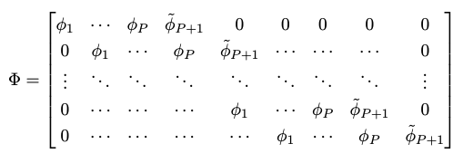

is a vector of unrestricted coefficients, and is a vector of restricted and unrestricted coefficients. and represent terms that map the observation period of the reported, smoothed returns to the latent, de-smoothed returns .

The reported returns are s.t. , and the latent returns are s.t. . Here, may or may not equal ; for example, when the reported returns are quarterly, and the factor returns are monthly[7]. To resolve this, we have the following formula that maps to :

If reported returns ( are quarterly, and latent returns () are monthly, , and (since each quarter consists of three months). And so, for the first quarter, and . When , the values in must add up to 1 for each month of the quarter (first, second, third). If not, months that fall earlier in the quarter will have a different long-run impact on NAV than months later in the quarter. For instance, if we have a single quarter lag, the first month of the quarter plus the first month of the previous quarter must add to 1. This implies that the sum of values in is 3 for quarterly data and 1 for monthly data[8].

In particular,

Also, the complete posterior distribution of is given by:

is a global precision parameter estimated for independent measurement variance. The precision parameter has a Gamma-distributed prior: with given shape hyperparameter, , and given inverse scale hyperparameter, . is an identity matrix.

The economic assumption behind the smoothing process is simple: that the observed fund returns () is a weighted average of the fund’s economic returns, , over the most recent () periods, including the current period. The econometric implications of this are that under the given assumption, the observed fund returns follow a MA process of order .

This restriction is similar to Getmansky et al [2004] where the observed return () for some period , is a weighted average of the “true” returns () over the most recent periods: , with to ensure that all information is eventually incorporated into observed returns, and for . In our case the observed returns are the reported returns, , the “true” returns are the latent returns generated using the factors, , and the terms (or as we notate them, terms) are generated using a multivariate normal distribution in the hierarchical Bayesian model, as follows:

Here, is as defined above, and is a global precision multiplier parameter, distributed as with given shape and inverse scale hyperparameters; is a matrix consisting of precision hyperparameters for ; and is a hyperparameter (i.e., fed into the model).

## A Brief Digression Regarding the Choice of Prior Distributions

The influence of well-behaved priors declines as data increases. Priors are, of course, essential in Bayesian analysis. In theory, Bayesian models exhibit a property known as ‘consistency.’ This means that as the sample size grows to infinity, the posterior distribution of the parameter of interest will converge to the “true” parameter value[9], assuming the model is correctly specified. In such a scenario, the choice of prior becomes less critical as the sample size increases.

That said, the use of the gamma distribution with an inverse scale parametrization above is convenient for several reasons:

1. Conjugacy: conjugate priors are advantageous for computational and analytical simplicity.
2. Positive Values: the gamma distribution is defined for positive values only.
3. Informative and Non-Informative Settings: the gamma distribution encodes both informative and highly diffuse priors. By adjusting its parameters, the priors may include strong prior beliefs or have minimal influence on the posterior, as reflecting the information available outside of the data.
4. Regularization and Stability: In Bayesian hierarchical models, the use of gamma priors can help in regularizing the estimates, particularly in complex models or in the presence of limited data. This can prevent overfitting and improve the model’s stability and predictive performance.

## Stochastic Search Variable Selection (SSVS)

|  |
| --- |
|  |
| *Figure 3: The probability mass function of a fund’s intercept term () from the SSVS (spike and slab) regression. The spike is apparent due to limited evidence of an intercept. The probability mass is concentrated around zero with a small positive tilt. There is low evidence of an intercept term.* |

As mentioned above, the regression performed to estimate is using the SSVS technique which defines prior regression coefficient variances consistent with inclusion or effective exclusion. In other words, it is a predictor selection technique. Such techniques commonly focus on which predictors to retain, though they also aim for improved predictive performance through developing an encompassing model, or model simplification without adversely affecting predictive accuracy (Piironen and Vehtari [2017]). Formal model choice is simplified for normal linear regression, as marginal likelihoods may be obtained analytically, but for many predictors, comparison of the many possible models becomes infeasible.

An imperfect analogy is stepwise regression using AIC or BIC as a selection criterion. However, when the number of regressors is large, testing of each model may be computationally prohibitive. A common workaround is a heuristic method to restrict attention to a potential subset of regressors, i.e., include or exclude variables, based on considerations (say).

SSVS uses a Bayesian approach with a normal mixture model for regression analysis. In this method, selector variables are employed to pinpoint which subsets of predictors are worth considering. It works by identifying those predictors that have a higher chance of being relevant, based on their posterior probability. Gibbs sampling[10] is standard when estimating these models. The MCMC approach samples from the distribution of all possible subsets of predictors. The subsets that show up more often in these samples are considered promising because they have a higher probability of being relevant.

We use the SSVS technique of George and McCulloch [1993], also known as a spike and slab regression. The term was coined by Mitchell and Beauchamp [1988] and referred to the prior for the regression coefficients used in their Bayesian hierarchy. This prior was chosen such that the regression parameters were mutually independent with a two-point mixture distribution made up of a uniform flat distribution (the slab) and a degenerate distribution at zero (the spike).

|  |
| --- |
|  |
| *Figure 4: The probability mass function of a fund’s intercept term (β0) from the SSVS (spike and slab) regression. Though we see a spike here, the bulk is in the long right tail representing substantial upside and a significantly greater weight of evidence for a positive alpha. This fund has over two years of history.* |

Ishwaran and Rao [2005] characterize a spike and slab model as being any model with a Bayesian hierarchy specified as follows:

Here, is the regression vector, and is its hypervariance matrix. The prior for the hypervariance plays a critical role in how effective the technique is for variable selection. A successful and populat choice of are priors that make use of the mixture distributions involving a spike near zero. In George and McCulloch [1993], the prior for was assumed to have a two-component distribution of the form:

The value for (the spike) is chosen as some small value, where “small” is typically based on the data at hand, while , also data-specific, is chosen so that (the slab) is sufficiently large. Selecting the two hyperparameters in this way allows to be small or large, and this in turn enables the posterior of to shrink towards zero or be some nonzero value. The values are complexity parameters that influence the likelihood of a coefficient being shrunk towards zero. In principle, each variable can have a unique complexity value, but a common practice is to set in which case the prior is referred to as an indifference prior.

GMAM 3 uses a Bernoulli prior on , the selector variable:

Here, the probability of factor selection , depends on hyperparameters and . , , is a vector and selector variable used to determine which of the thirteen factors are economically significant in a probabilistic sense. Initially, each of the factors have an equally likely chance of being included[11]. Conditional on the factor being in the regression, specify a prior distribution for the regression coefficient associated with that variable. GMAM 3 uses a multivariate normal:

Here, is the prior mean of conditional on exclusion (); is the shift in the prior mean of conditional on inclusion (); is a vector – a function of which adjusts for sparsity; is a matrix, with ; and is the variance of the spike distribution as a fraction of the slab variance. And finally, , , and are all gamma-distributed with shape and inverse-scale hyperparameters as shown earlier.

|  |
| --- |
|  |
| *Figure 5: The probability mass function of a fund index intercept term (β0) from the SSVS (spike and slab) regression. This index has almost twenty years of history and clearly shows positive alpha, though its magnitude is still uncertain.* |

# Conclusion

We use a hierarchical Bayesian model to generate fund returns when data is sparse and noisy. The data generation process includes de-smoothed returns, generated using a spike and slab regression, and re-smoothed returns used to mimic reported returns. Our technique provides a systematic and rigorous way by which fund performance can be quantified.

# References

1. David Geltner. Estimating market values from appraised values without assuming an efficient market. The Journal of Real Estate Research, 8(3):324–345, 1993.
2. Edward I. George and Robert E. McCulloch. Variable selection via gibbs sampling. Journal of the American Statistical Association, 88(423):881–889, 1993.
3. Mila Getmansky, Andrew W. Lo, and Igor Makarov. An econometric model of serial correlation and illiquidity in hedge fund returns. Journal of Financial Economics, 74(3):529–609, 2004.
4. Hemant Ishwaran and J. Sunil Rao. Spike and slab variable selection: frequentist and bayesian strategies. The Annals of Statistics, 33(2):730–733, 2005.
5. Steven N Kaplan and Antoinette Schoar. Private equity performance: Returns, persistence, and capital flows. The Journal of Finance, 60(4):1791–1823, 2005.
6. Harry M. Markowitz. Portfolio selection. Journal of Finance, 7(1):77–91, 1952.
7. T.J. Mitchell and J.J. Beauchamp. Bayesian variable selection in linear regression. Journal of the American Statistical Association, 83:1023–1036, 1988.
8. Ludovic Phalippou. The hazards of using irr to measure performance: The case of private

equity. 2008. https://papers.ssrn.com/sol3/papers.cfm?abstract_id=1111796.

1. Juho Piironen and Aki Vehtari. Comparison of bayesian predictive methods for model selection. Statistics and Computing, 27:711–735, 2017.
2. Morten Sorensen and Ravi Jagannathan. The public market equivalent and private equity performance, 2013. https://papers.ssrn.com/sol3/papers.cfm?abstract_id=2347972.

# Factor Definitions

|  |  |
| --- | --- |
| Factor Name | Index |
| Alt Commodities | Bloomberg Commodity Index |
| Alt HF Crowding | *Difference Between:*  Barclays Form 13 Filing;  Russell 3000 Total Return Index |
| Alt Oil | *Average of:*  Middle East Crude Oil;  WTI Crude Oil;  Brent Crude Oil |
| Alt Trend | Credit Suisse Managed Futures Index |
| Emerging Markets | *Difference Between:*  MSCI Emerging Markets Index (PR);  MSCI ACWI (PR) |
| Equity Market | MSCI ACWI (TR) |
| Equity Momentum | *Difference Between:*  MSCI ACWI Momentum NR USD;  MSCI ACWI IMI |
| Equity Quality | *Difference Between:*  MSCI ACWI Quality NR USD;  MSCI ACWI IMI |
| Equity SmallCap | *Difference Between:*  S&P BMI Global Small-cap PR;  S&P Global Broad Market PR |
| Equity Value | *Difference Between:*  S&P BMI Global Value PR;  S&P Global Broad Market PR |
| Fixed Credit | *Difference Between:*  Bloomberg US Corporate High Yield Index;  Bloomberg Barclays US Aggregate Bond Index |
| Fixed Duration | Bloomberg U.S. Treasury: 7-10 Year Total Return Index Value Unhedged |
| US Dollar | US Dollar Index |

# Variable Names and Definitions

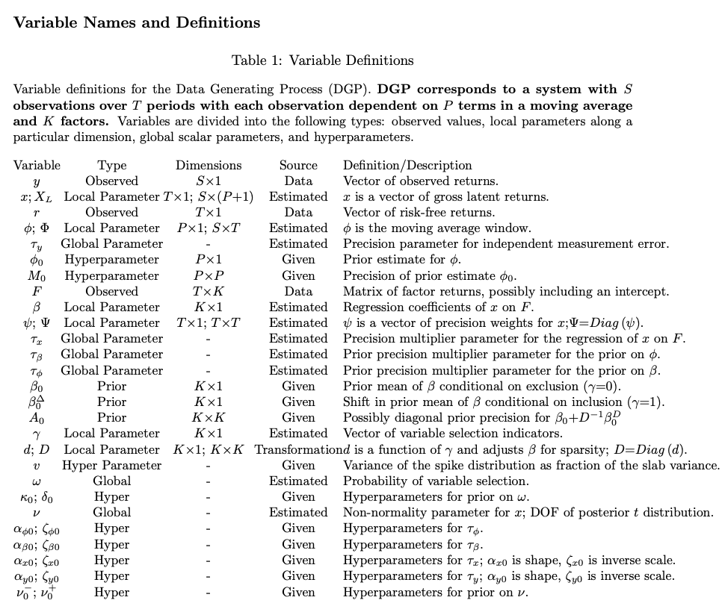

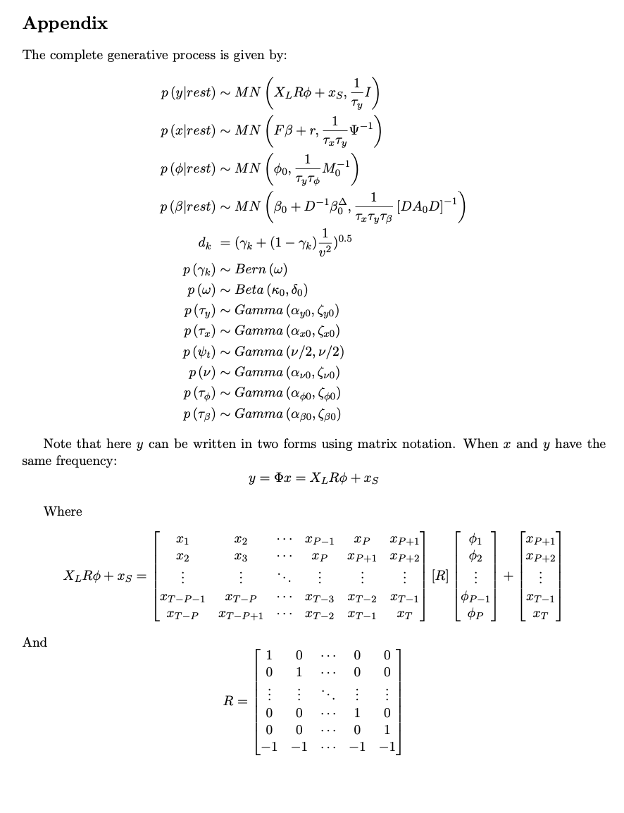

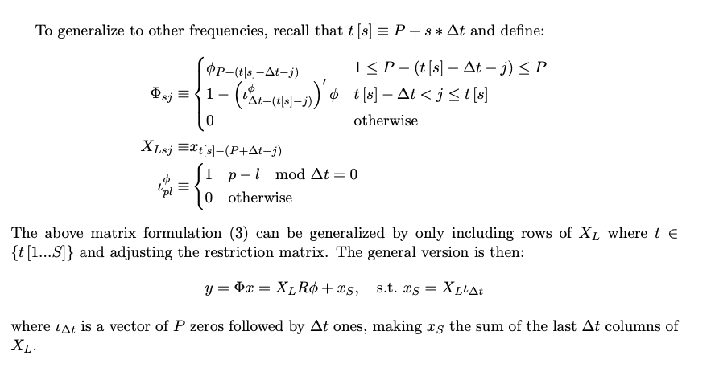

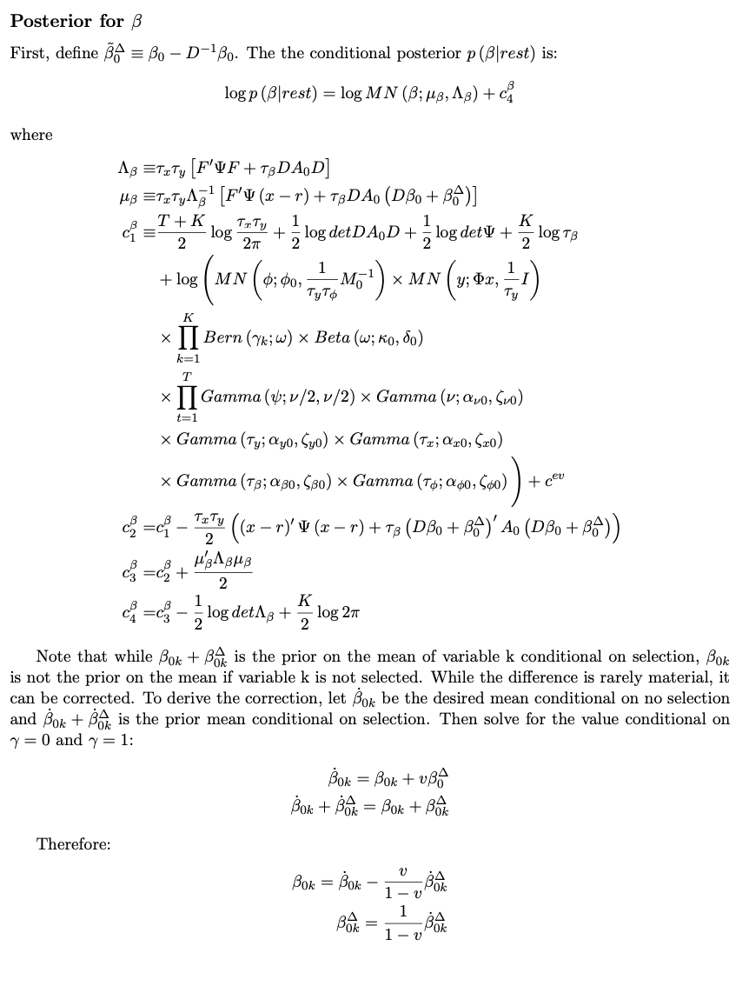

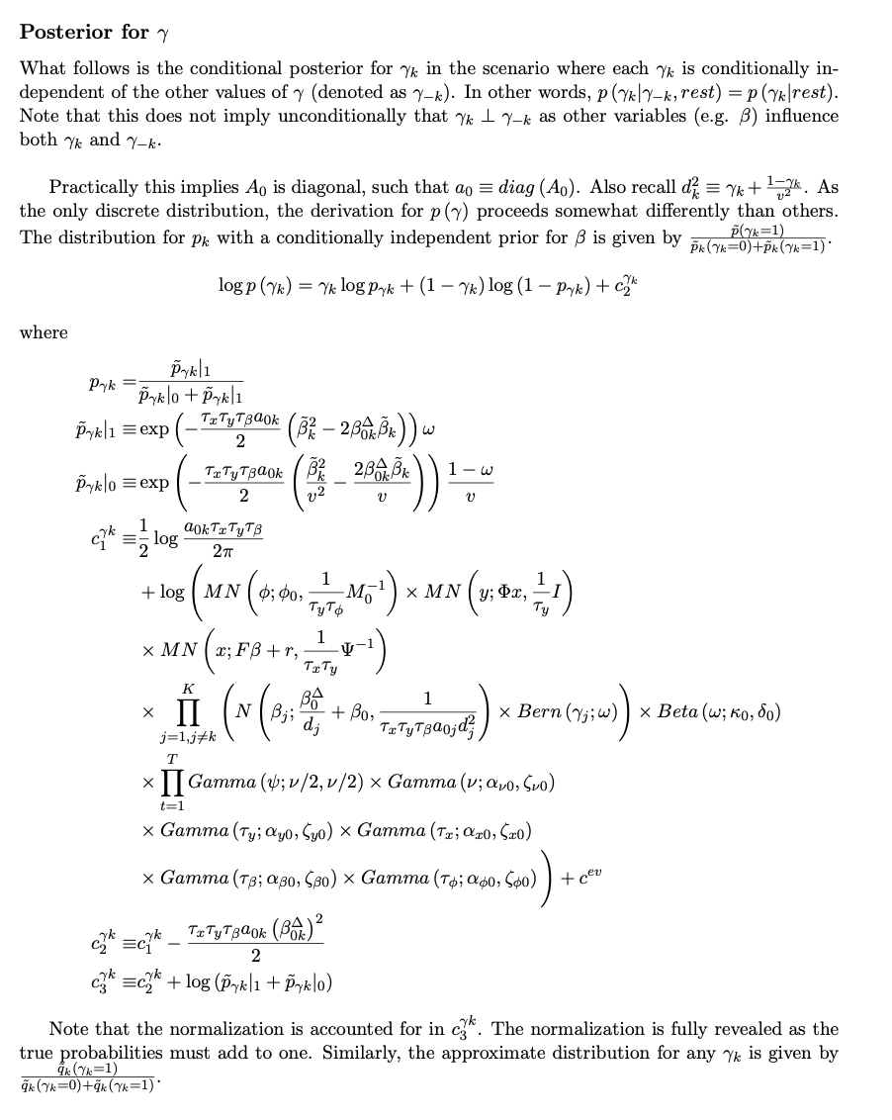

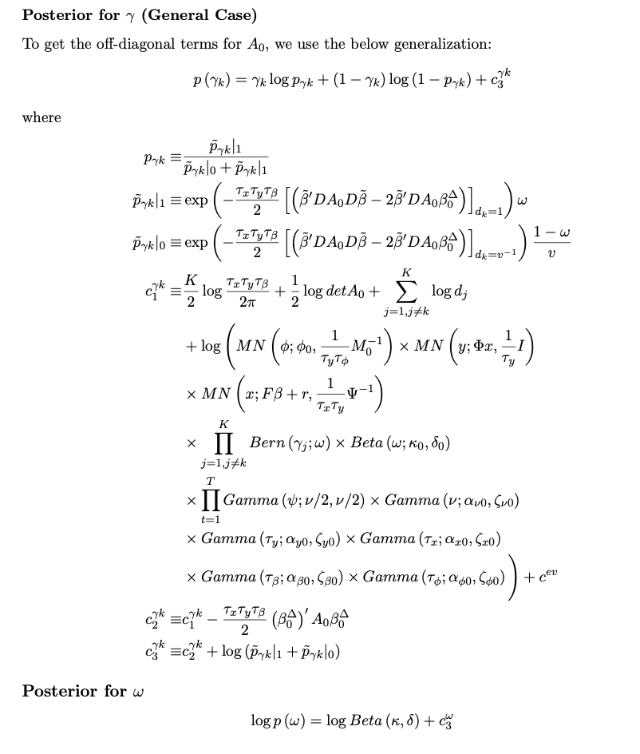

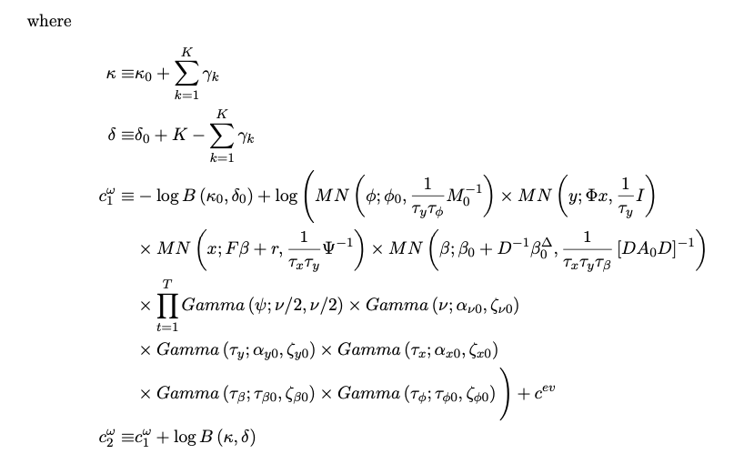

1. Source: https://www.bain.com/insights/topics/global-private-equity-report/
2. Source: https://www.mckinsey.com/industries/private-equity-and-principal-investors/our-insights/mckinseys-private-markets-annual-review/
3. Source: https://www.bloomberg.com/professional/blog/sure-time-to-grasp-the-potential-of-structured-products/
4. Source: https://icapital.com/insights/practice-management/untapped-potential-alternative-investments-and-the-wealth-management-channel/
5. See, for example: https://pages.stern.nyu.edu/~adamodar/pdfiles/ovhds/ch5.pdf#page=43
6. They may not fully capture the complexities of PE investments, such as the strategic timing of cash flows and the long-term, illiquid nature of these assets.
7. Our factor returns are almost always monthly, as are the de-smoothed returns.
8. Note that the vector . For quarterly reported data, say where . Then   and the sum of all terms in   is 3. For monthly reported data, say where . Then   and the sum of all terms in here, is 1.
9. In the frequentist sense of the word.
10. Gibbs sampling is a statistical technique used for generating sequences of samples from the probability distribution of multiple variables. It's a kind of Markov Chain Monte Carlo (MCMC) method. It is particularly useful in scenarios where directly sampling from the joint distribution is difficult, but sampling from the conditional distribution of each variable is feasible.
11. Subject to a zero-exposure prior.